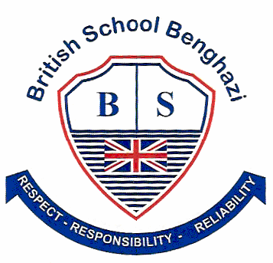
BSB NEWSLETTER

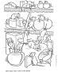

12 October, 2017

Certificates
Teachers appreciate those students who work hard, do well at school or do good things for others. To show that teachers notice when students do well either academically or socially, teachers have awarded them certificates.

28 September
Nursery: Salem
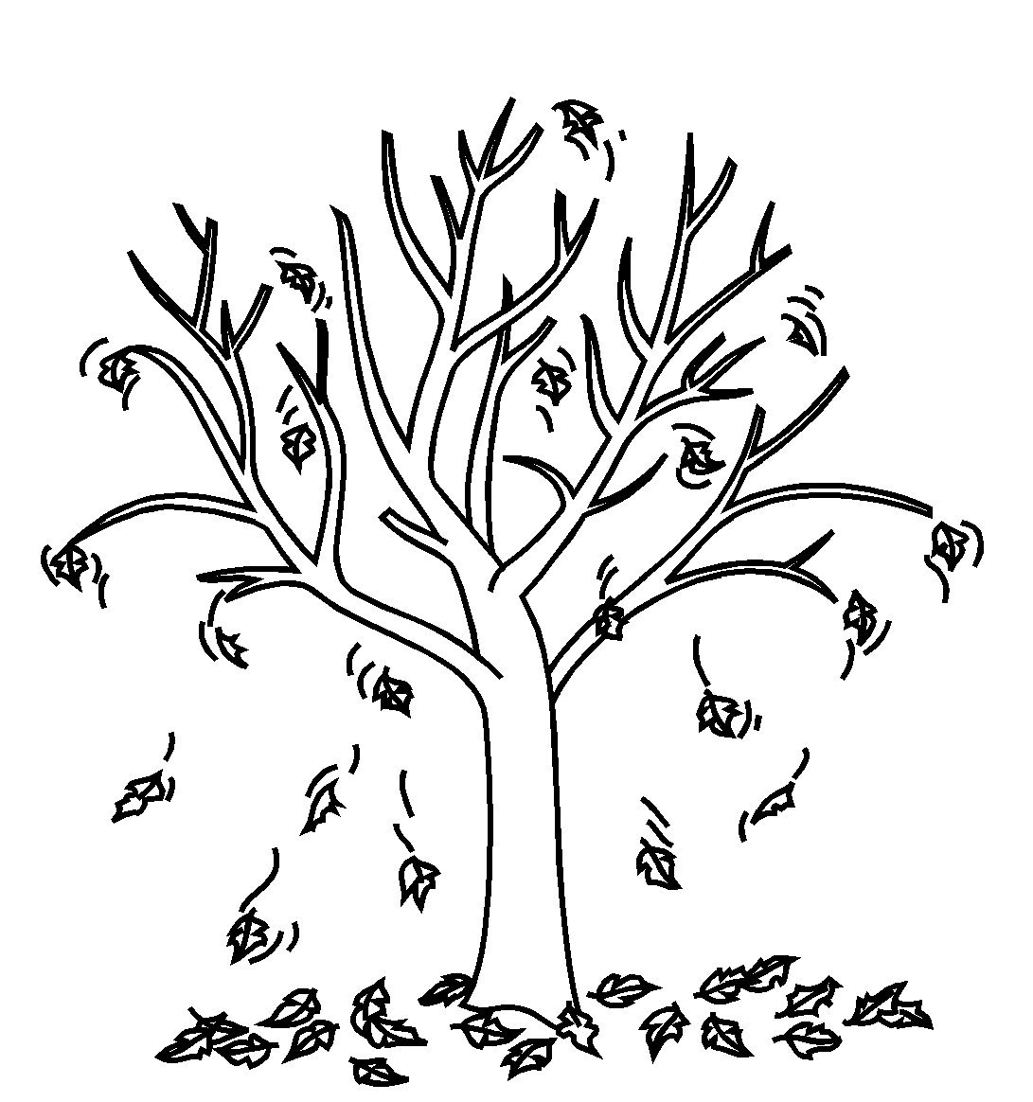

Year 1: Zeinab
Year 3: Mohab
Year 5: Malk
Year 6: Afnan
Arabic
Year 5: Narges
Year 6: Afnan and Thabit

October 5
Reception: Abdulsalam
Year 1: Jana
Year 3: Alia
Year 4: Mohamed Q.
Year 5: Mira
Year 6: Thabit
Arabic
The Year 4 class and some Year 6 students received awards from Ms Amina. Congratulations, everyone.

House Teams
Students are busy earning merit points for their house teams. It is good to see students earn merits for their school work or for their good behaviour. At the time of writing this newsletter the house teams had earned the following points.
Blue | Green | Red | Yellow
24 | 73 | 77 | 66

After-school Activities
After-school activities at BSB began last week with students participating in five activities: Arabic Singing and Dancing, Chess, Cooking, Lego Fun, and Sports and Games.

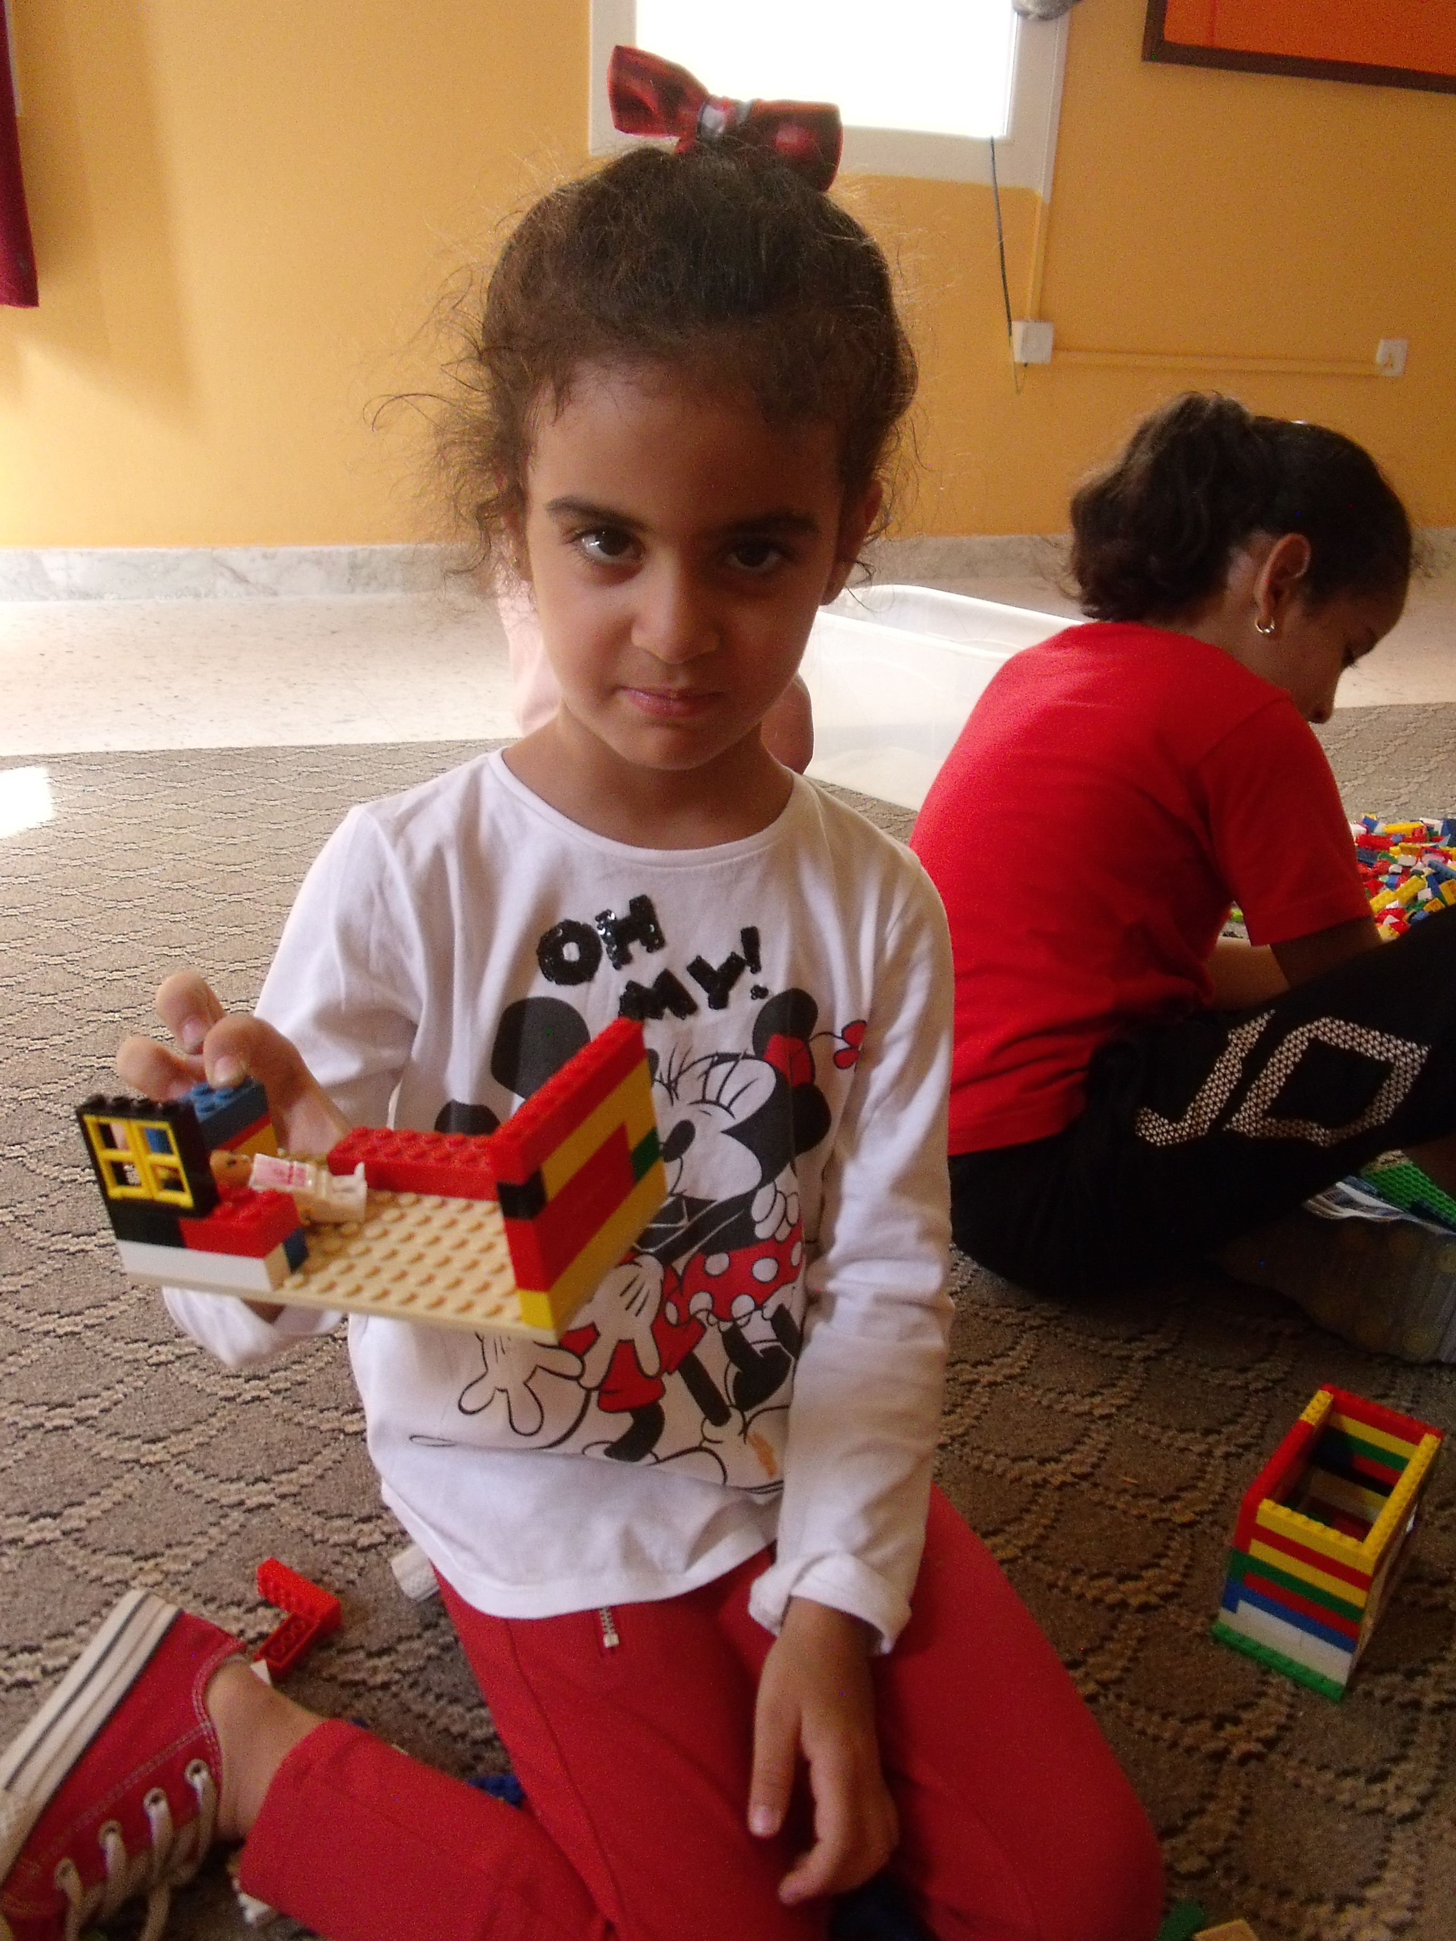
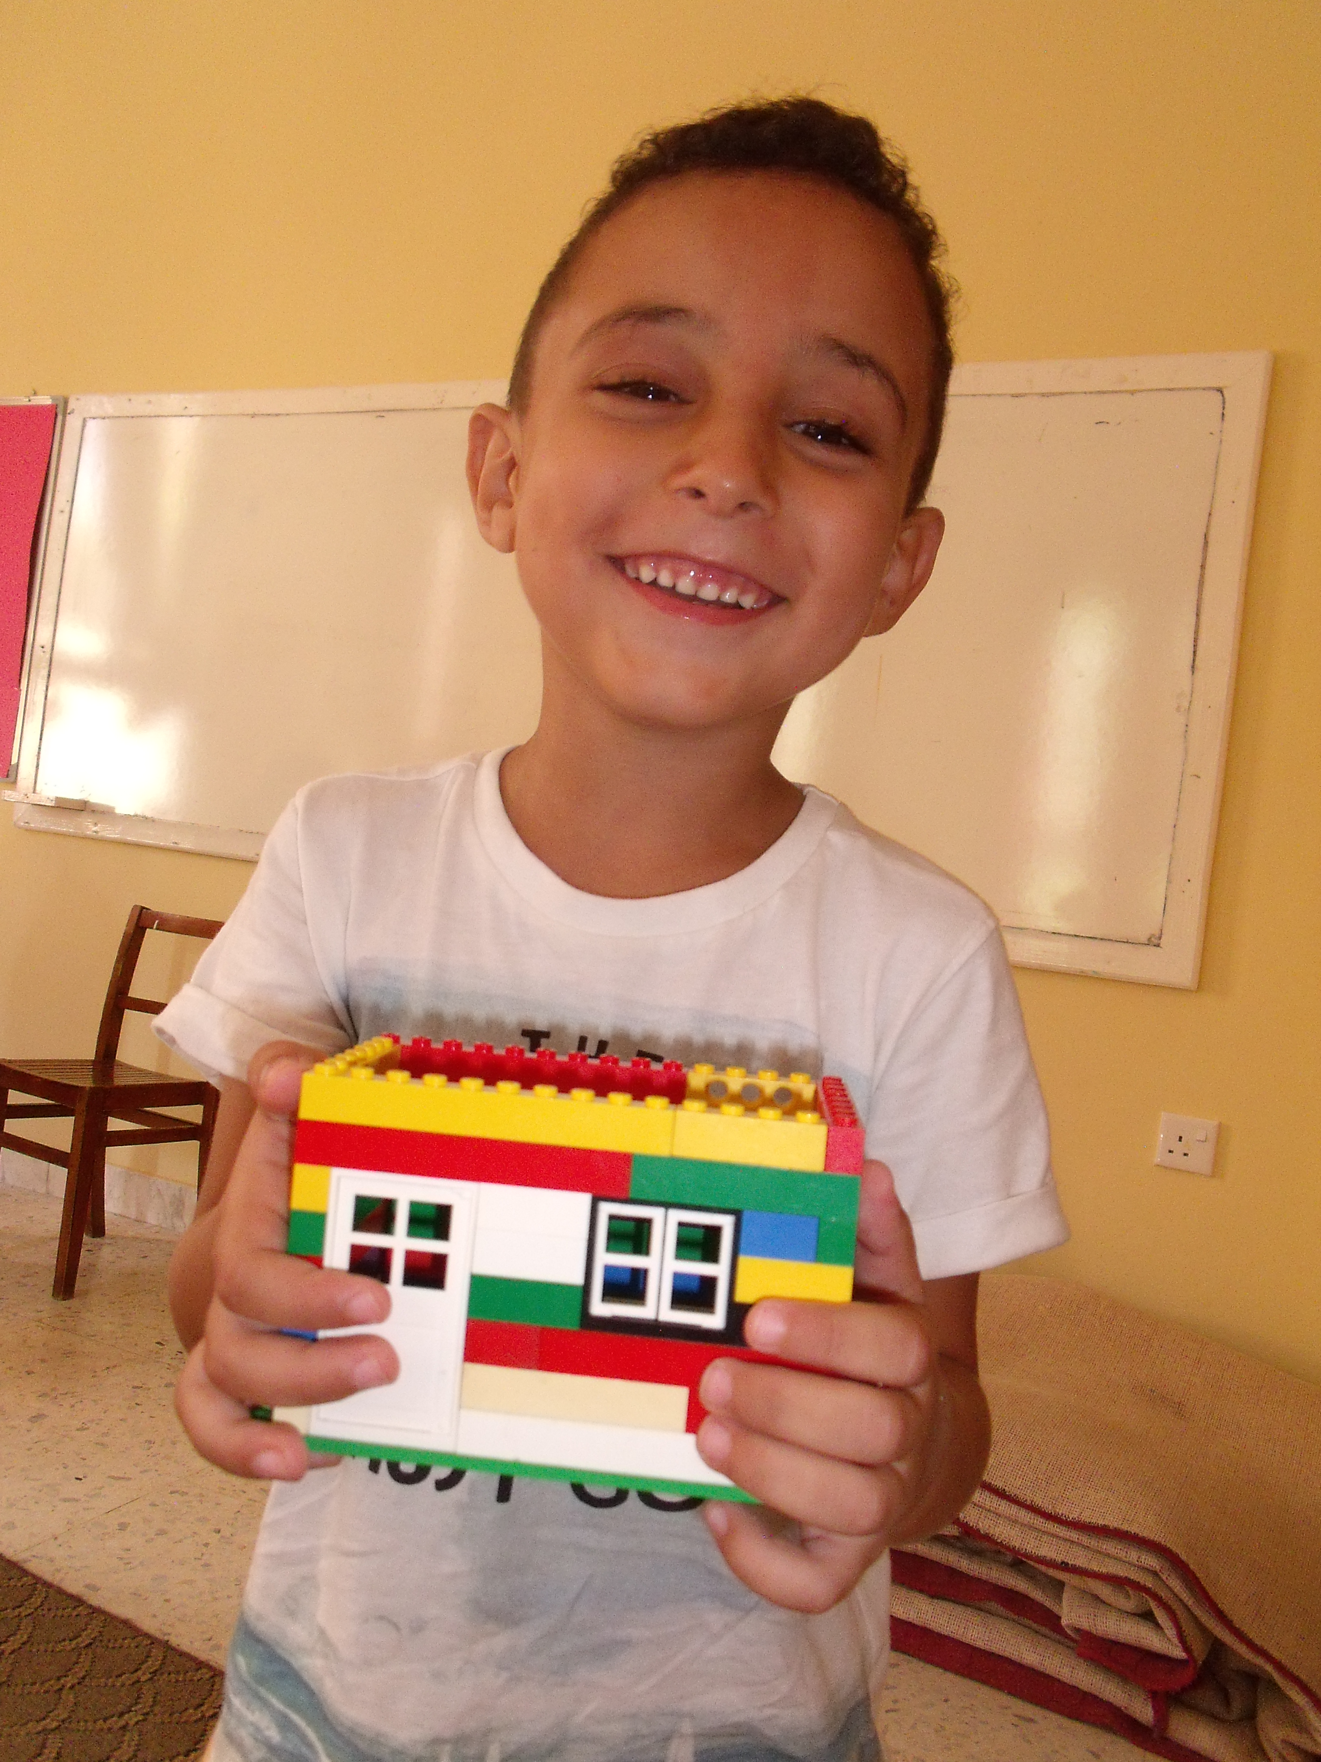
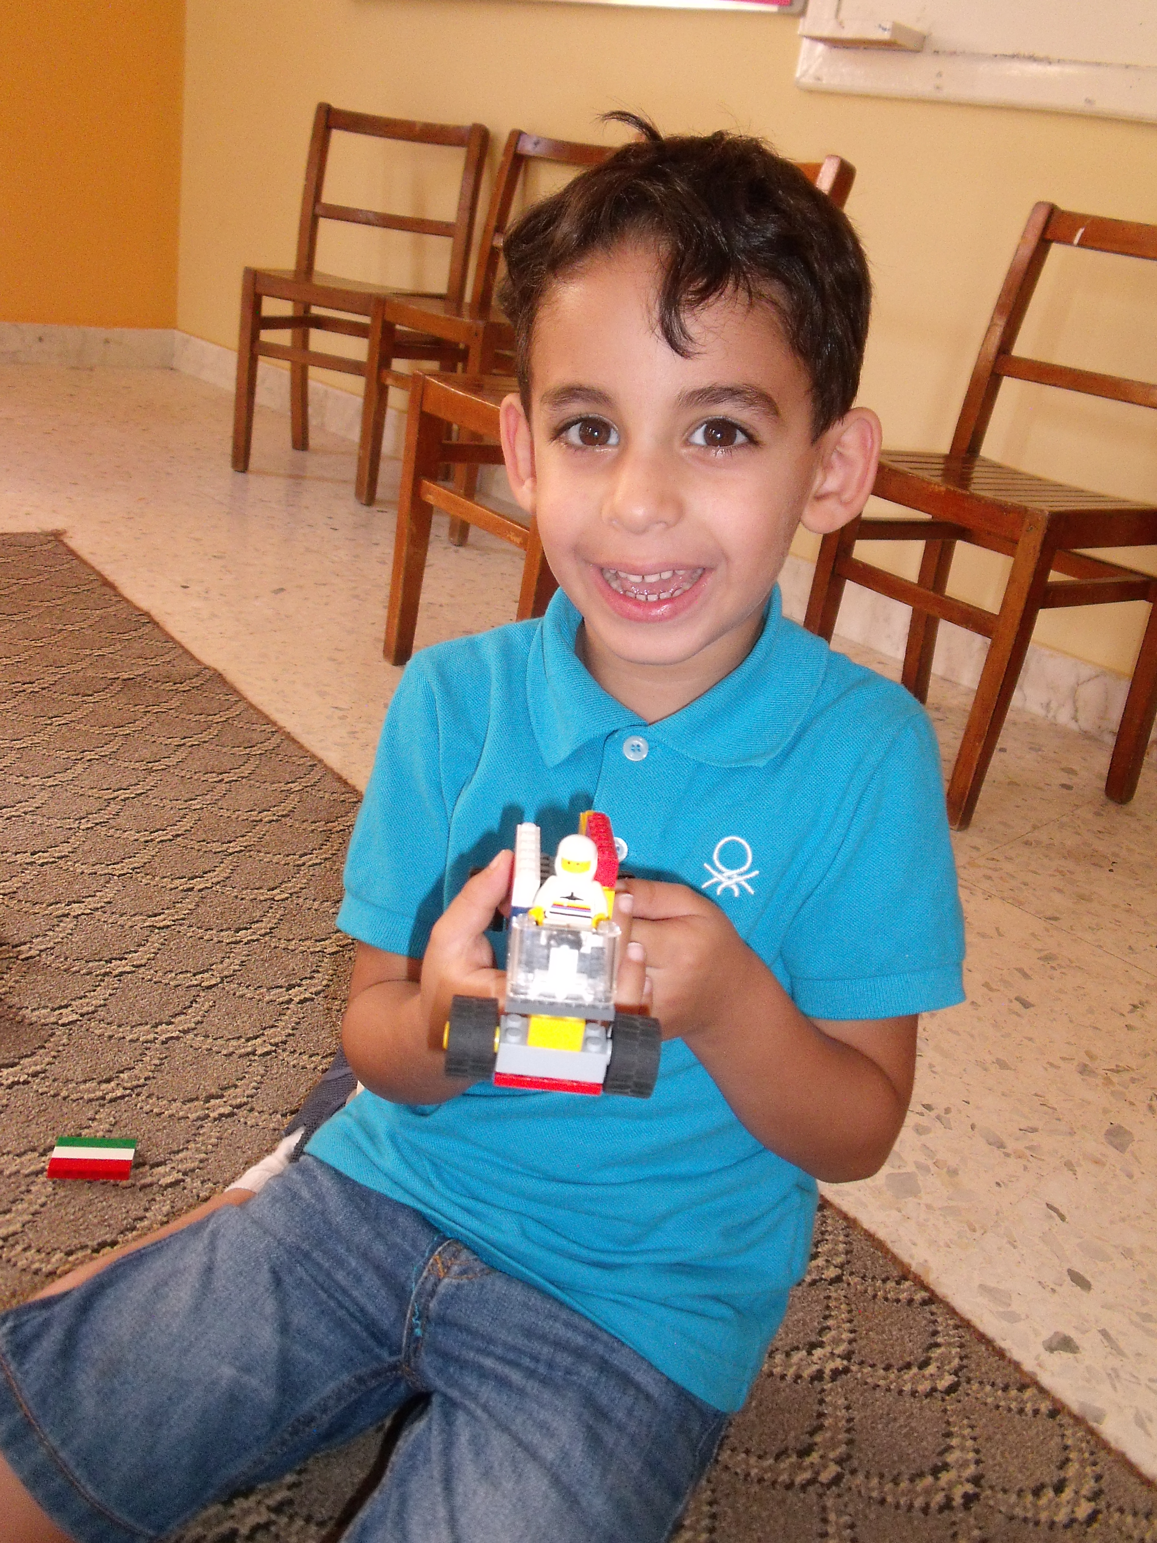

Lego Fun Activity
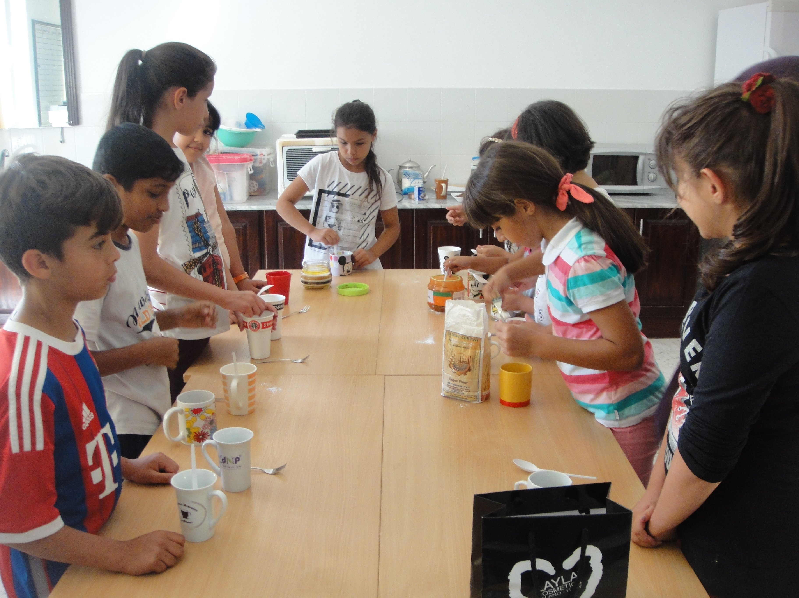
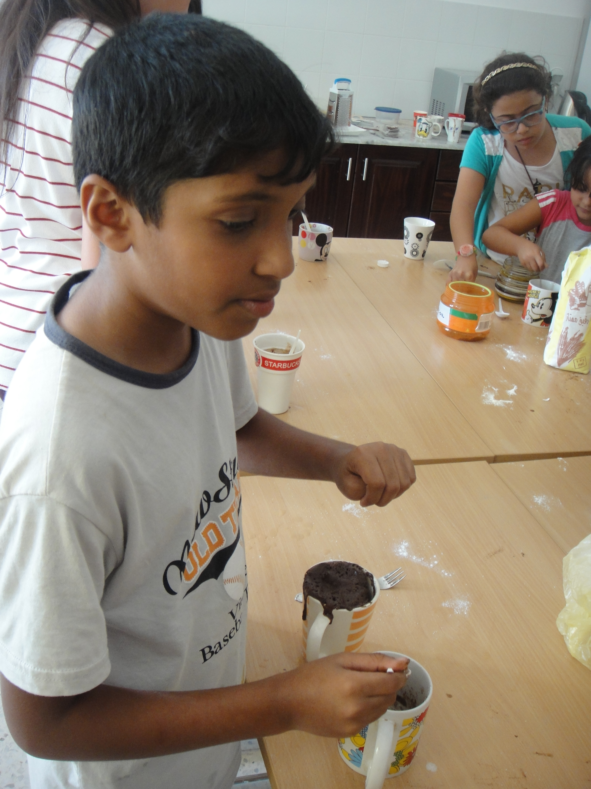

Cookery Activity
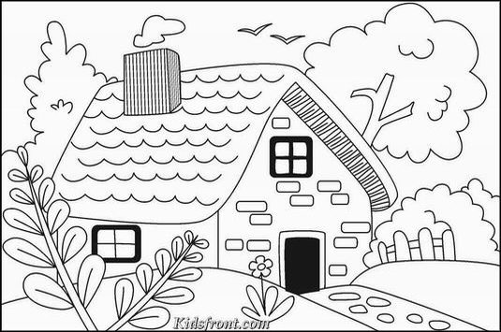
Spot the Differences
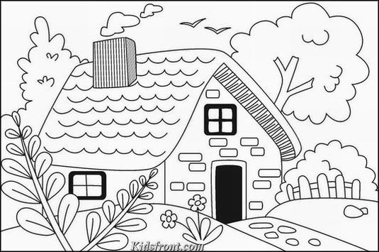
Did You Know? It is fall or some say autumn in the Northern Hemisphere. According to Dictionary.com, before the 1600s, the term "harvest" was used to describe this time of year, because farmers would gather or “harvest” their crops and prepare for the coming winter. As time went by, poets would write the phrase, "the fall of leaves" which was shortened to "fall”. While the words “fall” and “autumn” mean the same, Americans usually refer to this time of year as “fall”, while the British use the word “autumn”.

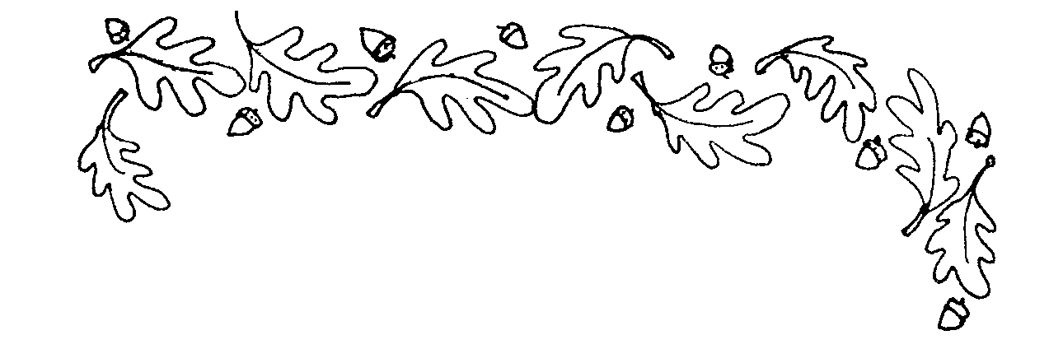

Remember: Check out school photos on the school’s website
www.britishschoolbenghazi.org

