
BSB NEWSLETTER

1 March, 2018

Certificates
Teachers appreciate those students who work hard, do well at school or do good things for others. To show that teachers notice when students do well either academically or socially, teachers have awarded them certificates.

15 February
Reception: Malak
Year 2: Rital
Year 3 ICT: Alia
Year 5: Hamida
Year 5 ICT: Rimas K.
Year 6 Mad Minute: Afnan

22 February
Year 3: Osama
Year 4: Mostafa
Year 6 Mad Minute: Afnan, Nikhilesh and Suliman
What is it, Rabbit or Hare?
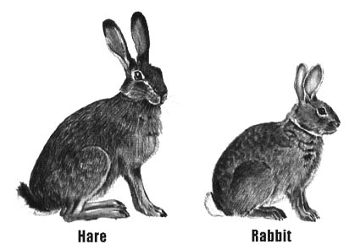

Hares and rabbits look similar, and some may hop to the conclusion that they're the same animal. Not so fast.
What's the difference between a rabbit and a hare? The short answer: Hares and rabbits are in the same family, Leporidae, but they're different species; like sheep and goats are different species. Hares are also larger, have longer ears, and are less friendly than rabbits.
The greatest difference is seen in baby hares versus baby rabbits. Newborn hares, called leverets, are fully developed at birth—furred with open eyes—while newborn rabbits, called kittens or kits, are born undeveloped, with closed eyes, no fur, and must be kept warm by their mother.
Source: news.nationalgeographic.com



Upcoming Assemblies
- Nursery / Reception: Thursday, 8 March
- Years 1, 2 and 3 Arabic: Thursday, 15 March

Production
Rehearsals are moving along but a lot of practicing is still needed. All actors must have their lines memorised.

Book Week At BSB
A week of celebrating books, and all the wonderful information, adventures and fun they can bring, was held at BSB this week. The week was packed with different activities that showcased books.
On Sunday, the week began with ‘Buddy Reading’ where students from the Junior classes met with Infant students. The Juniors read stories to the Infants who were excited to have another student read to them. At the end of the day all staff and students met in the hall for D.E.A.R. time. This means Drop Everything And Read. Everyone relaxed in the hall and spent time simply enjoying a good book.
The Junior House Book Quiz was held on Monday. Students from each house team from Years 3 to 6 participated in the quiz. Questions about books were asked and the students earned house points for their teams.
On Tuesday, all students participated in the ‘Where’s Wally’ search. Students from each house team searched the school for Wally. In fact, there were many Wallies hidden around the school. Each Wally had a letter on him. When each house team found all the Wallies for their team, they then unscrambled the letters to make a book title. Once they found out the name of the book, a teacher read the story to them. Later on that day, the Infants participated in the Infant Book Quiz. They answered questions about books and stories they have read.

Students at BSB went fishing for a story on Wednesday. Students went fishing and caught story parts. They then thought of a story where all the parts fit in. This made for some very creative, fun stories. At the end of the day, all staff and students met in the hall for D.E.A.R. time again. It was a nice way to end a day of school.
On Thursday, Junior students met with Infants and Junior reading buddies read to the infants. It is always great to share a good book. At the end of the day, the students met for a celebration of Dr. Seuss’s birthday. He was born on 2 March, 1904. Dr. Seuss books are a favourite even today and the school enjoyed a cartoon of his book ‘The Lorax’.
Books are always important at BSB, but Book Week is a special time to truly celebrate our love of books. A big thanks goes to Ms Valerie for organising our week.
The Long Haul
A Book Review by Thabet Naser – Year 6
The Long Haul, by Jeff Kinney, is a fictional story. It is about a kid who has bad luck and whenever he goes with his family on a holiday it turns into a disaster. This book is from a series called Diary of a Wimpy Kid, that kid was sure wimpy. But, my favourite book is the long Haul.
The long Haul is about a kid called Greg Hefley who always gets in trouble. In this story he goes on a road trip and it turns into a nightmare. First their car broke down so they had to wait for someone to take their car to the mechanic to get it fixed. After ages they got the car to the mechanic. They needed a place to sleep in, so they went to this disgusting motel which was infested with rats and insects, plus a weird man sometimes appeared in Greg's bed.
My favourite part is when Manny, Greg’s small brother, goes to the carnival and says a random number and he wins a pig. When his mother says, who has pigs as pets and forgot that she was in the country side, and it turned that everybody had a pig as a pet. It was my best part because it made me laugh like anything.
I highly recommend this book for young people who like jokes. Maybe some people like the Getaway, Rodrick Rules or Double Down. There are multiple choices. I loved all of the books, but the reason that I prefer the Long Haul is because it made me laugh a lot and I enjoyed it.
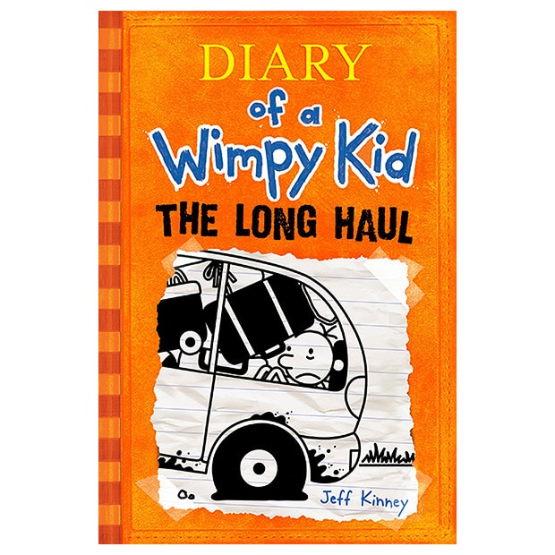

The Frightening Hole
By Fatima Elsahli – Year 4
“Help me there is a nervous rabbit is chasing me!” said an old queen. “Oh I fell in a black, nasty, frightening hole,” shouted the queen with a loud voice.
“I’m going to eat you,” whispered the monster with one eye.
“Oh my god,” whispered the old queen. There was a monster with one eye who caught her because there was a dragon who told him if anyone comes into that frightening hole catch them and put them into a cage until I come and I will decide what we are going to do with him or her.
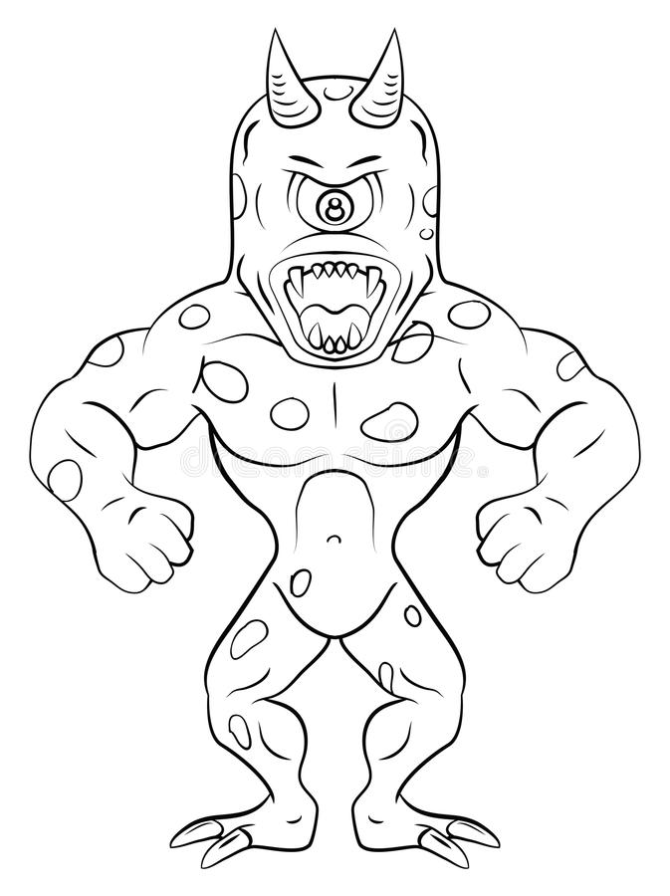
The dragon came “Well, well you caught the queen for I was looking for her and she is right in front of my face,” said the dragon. “How did you catch her?” asked the dragon creepily.
“I caught her by my magical light” replied the monster with one eye.
Then there was a zombie who said “ZOMBIE, what are we going to do with her?” asked the zombie creepily. “Listen you three tomorrow we are going to do a picnic and we are going to eat her.
“No, please don’t eat me,” said the queen. So the monsters said we are going to eat you the day after tomorrow. The next day they found her skeleton thrown on the floor.

Cleaning Your Teeth
An Instructional Text by Lily – Year 3
What you will need:
tooth brush, tooth paste, water

What to do:
- Put some toothpaste on your toothbrush.
- Move your toothbrush in small circles until your teeth are clean.
- When you are finished, take the water and put it in your mouth the spit the water.

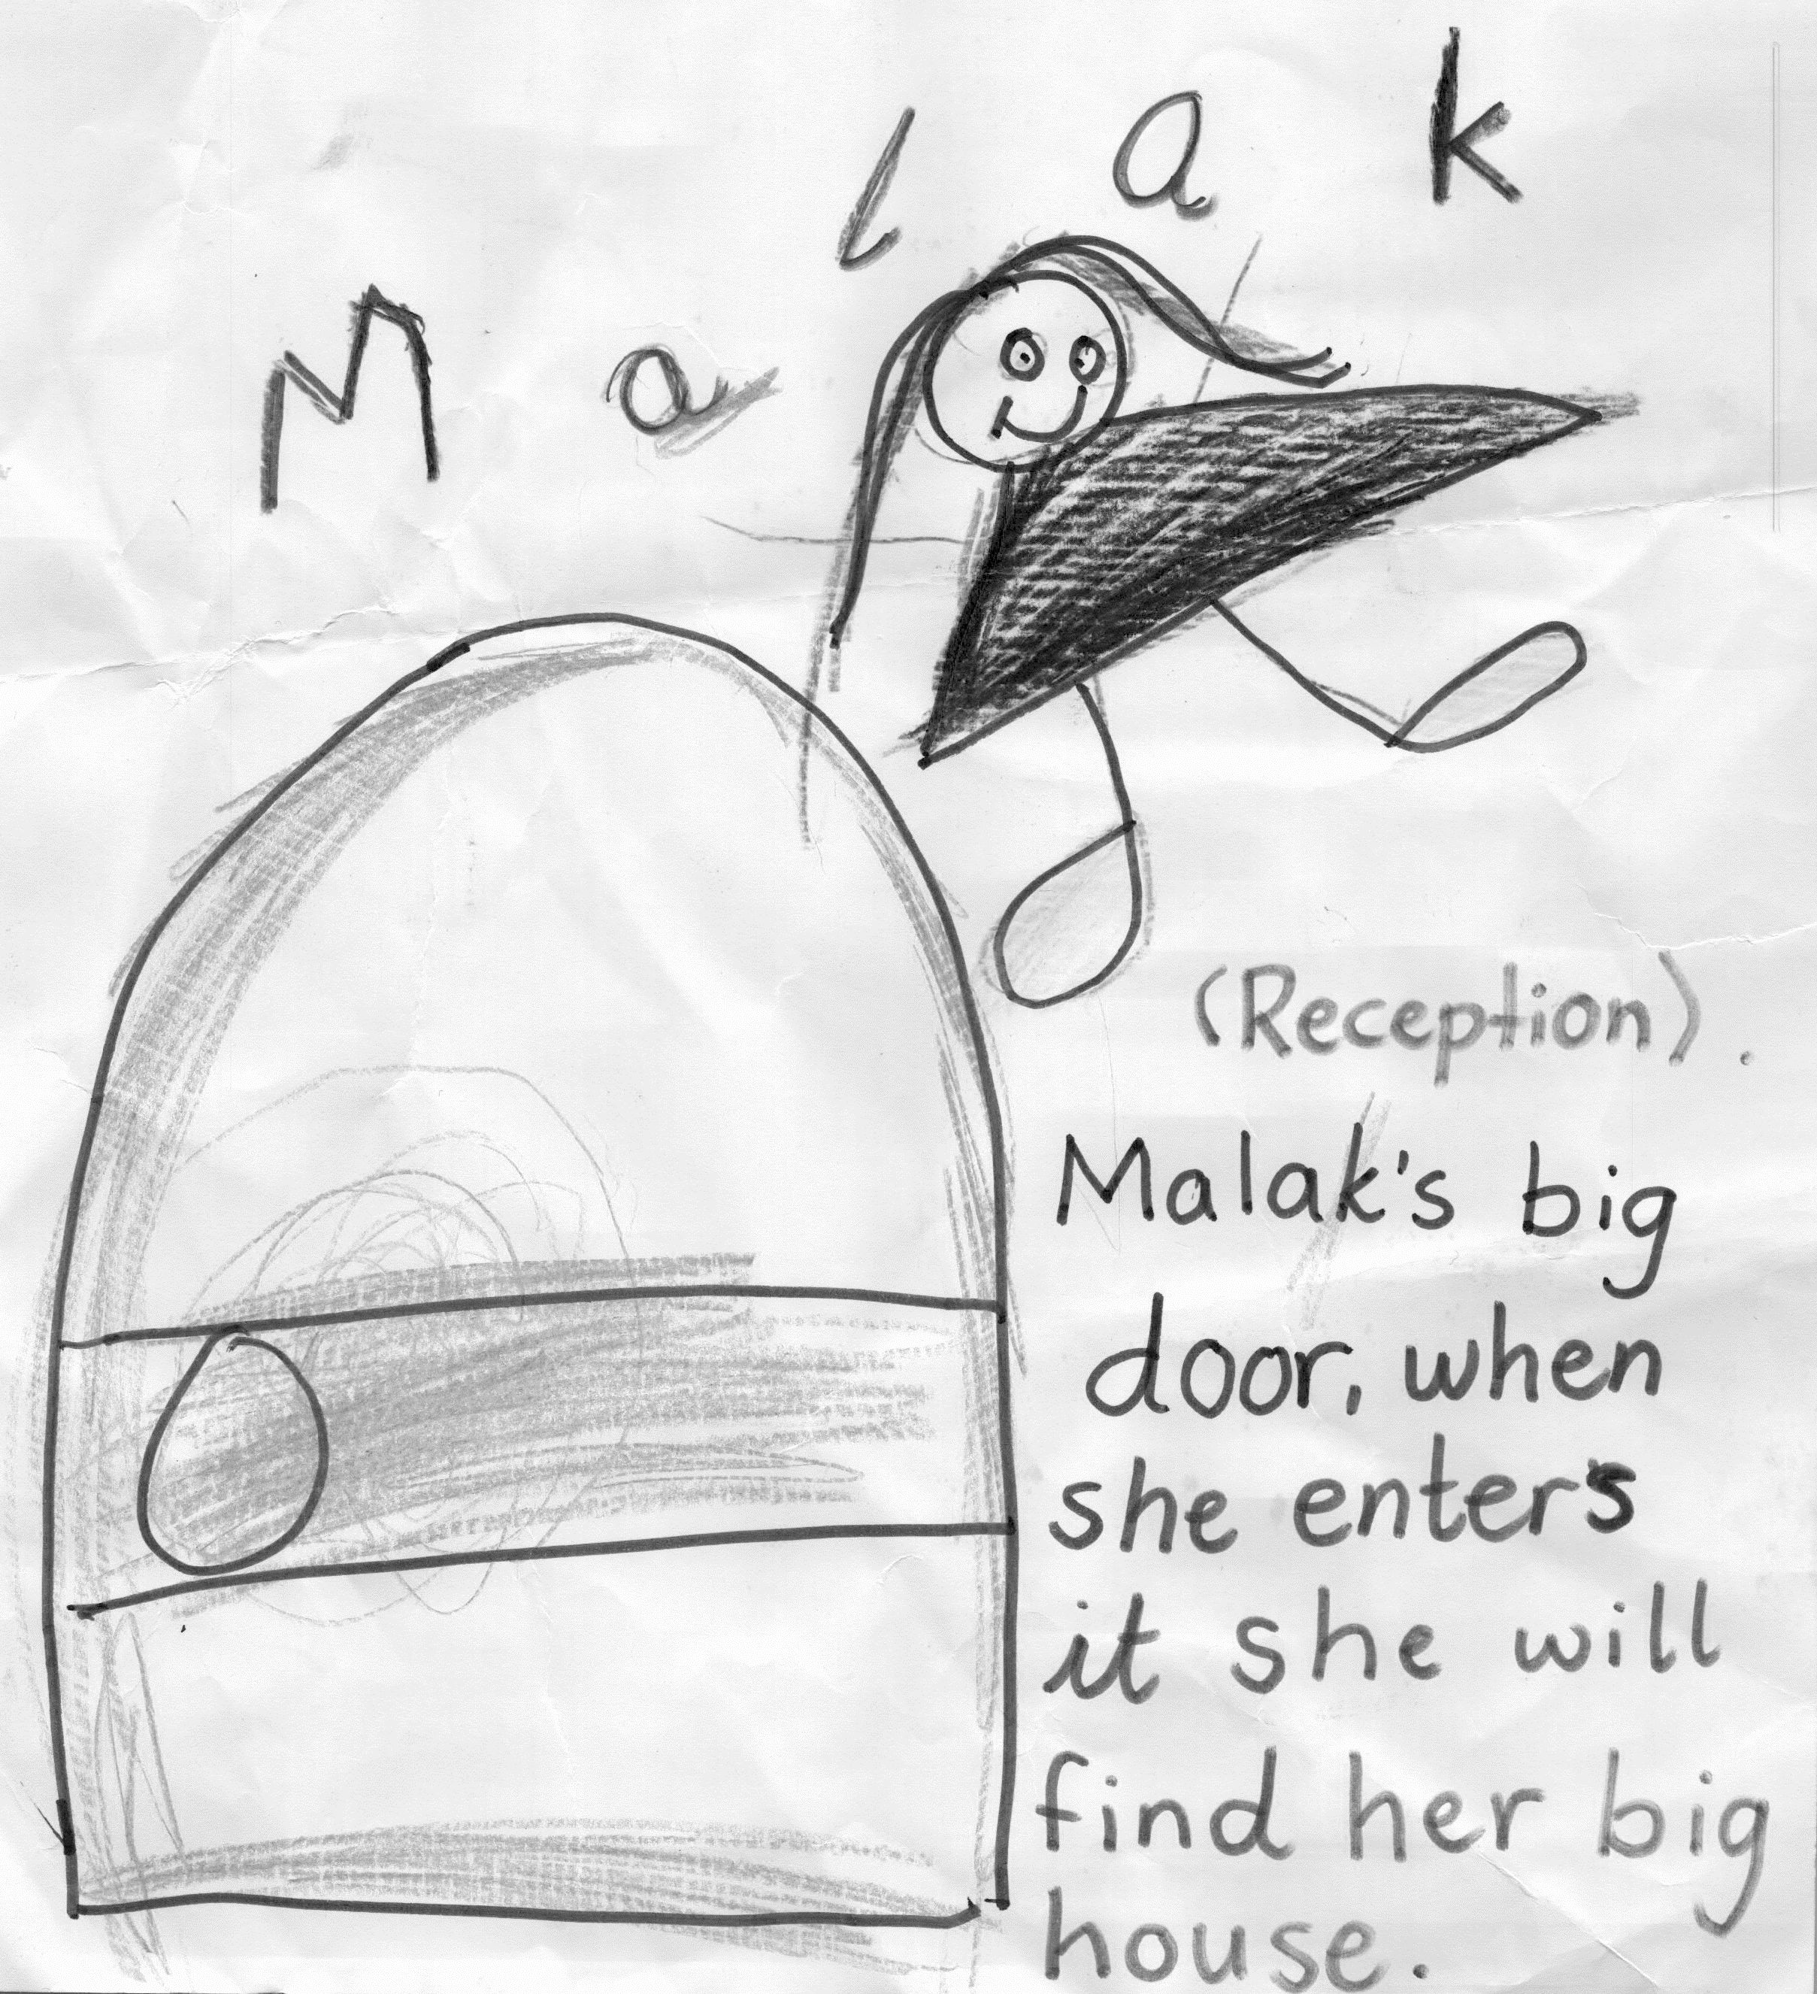
Malak Ferjani in Reception wrote her own story.

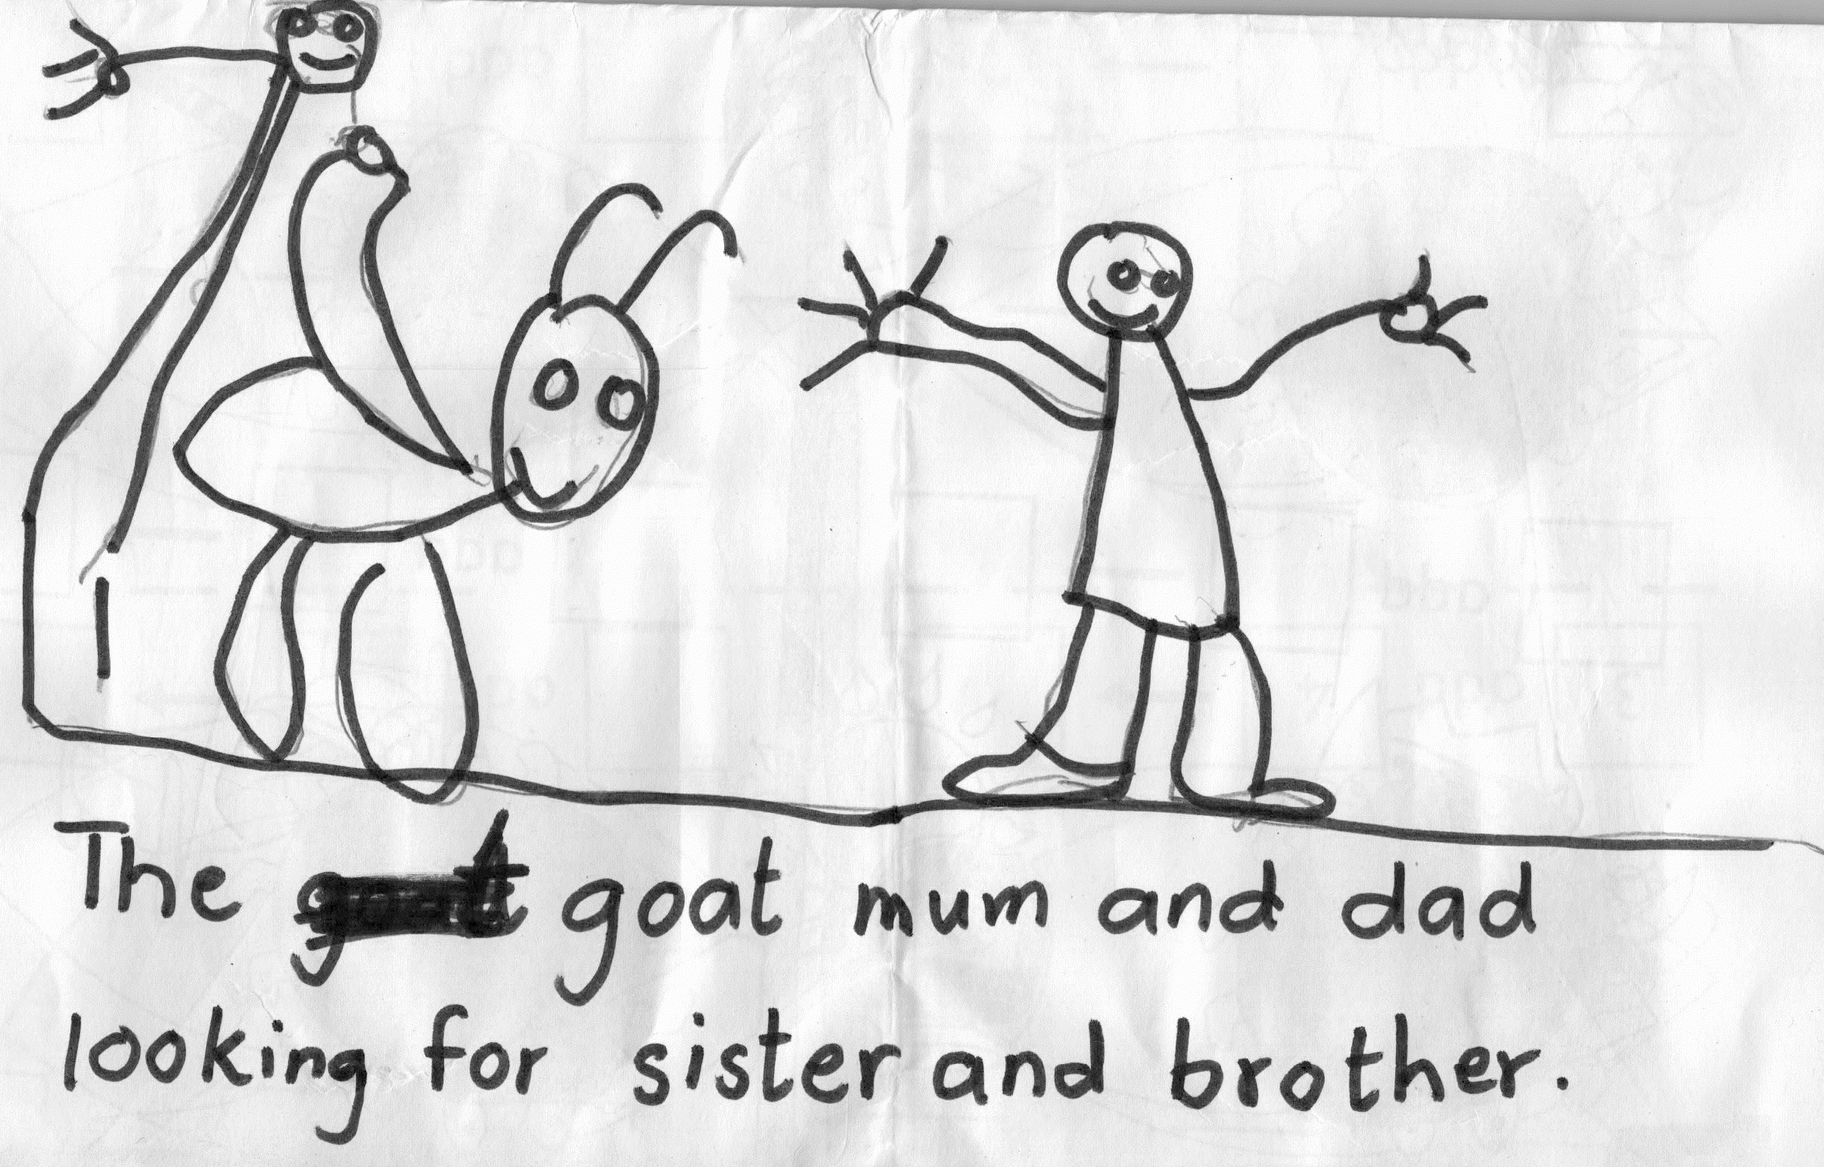
Khalifa Abdelmagid in Reception wrote a story for
Book Week.

Remember: Check out newsletters and school photos on the school’s website
www.britishschoolbenghazi.org

