BSB NEWSLETTER

School Calendar Changes

The school calendar has been changed. The seven school days at the end of Term 3 have been taken off. Seven days of the Spring Break have been replaced with these seven days. This means that school will end before Eid El-Fitr without losing any school days. A new school calendar is being sent home with this newsletter. We hope this makes it easier to plan your Eid Celebrations.

18 January, 2018

Certificates
Teachers appreciate those students who work hard, do well at school or do good things for others. To show that teachers notice when students do well either academically or socially, teachers have awarded them certificates.

7 December
Reception: Ali, Khalifa and Malak
Year 1: Roubeen
Year 2: Bozaid
Year 3: Osama
Year 4: Mohamed O.
Year 4 Arabic: Fatima, Jana, Lena, Mohamad and Riman
Year 5: Mariam
Year 5 French: Remas, Sarah and Zubair
Year 6 Mad Minute: Afnan
Year 6 Arabic: Afnan, Nikhilesh, Sulayman and Thabit

14 December
Year 3: All Students
Year 4: Fatima and Hoor
Year 6 Mad Minute: Nikhilesh and Thabit

11 January
Nursery: Zaineb
Year 5: Zubair
Year 6 Mad Minute: Nikhilesh

House Champions
The Red team won the house trophy for Term 1. They earned a total of 542 points. Congratulations to all students in the Red house. We will start over and look forward to finding which team will claim the house championship for Term 2.

Production
The rehearsals for the annual production are underway this term. The play this year is called ‘Zoom!’ It is a musical based on the old fable ‘The Tortoise and the Hare’. Rehearsals will be held every Monday and Wednesday. Rehearsals end at 3:00. Please pick up your child on time.
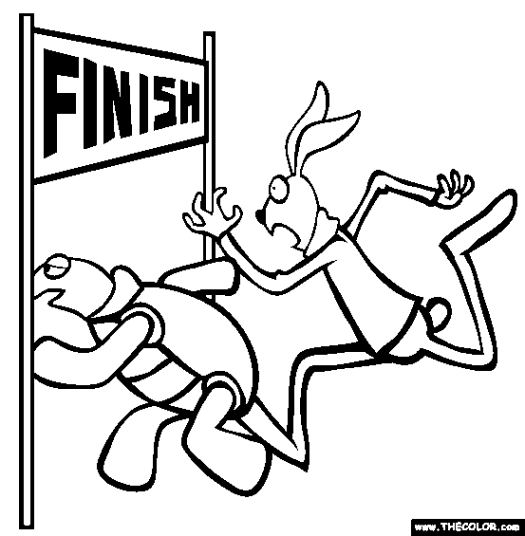

Term 1 Reports
This is a reminder to all parents to please sign and send in your children’s Term 1 reports along with the folders.

School Rules
Please remember the following:
- BSB is trying to promote healthy eating. Do not send sweets, crisps or soft drinks to school.
- Girls do not need to wear jewellery to school. However, small stud-type earrings are allowed.
- Please make sure your child is at school before 8:00. Late students are a disruption to the lesson. This is not fair to students who are at school on time.

Plastic Water Bottles
It is quite shocking to see how many plastic water bottles are thrown away at our school each day. Please send a reusable water bottle to school with your child. It can be filled at school. This will not only save you money but also help reduce pollution in our environment.
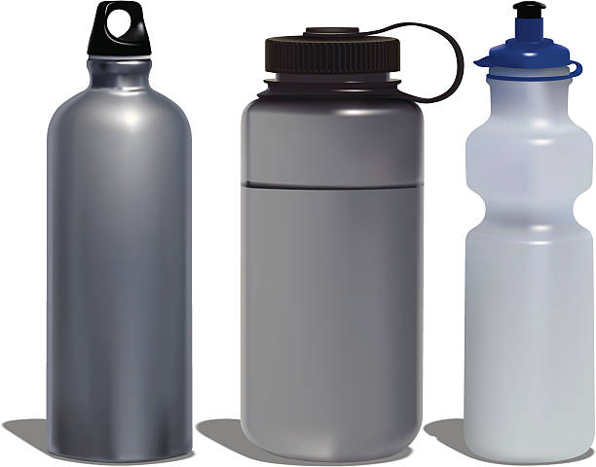
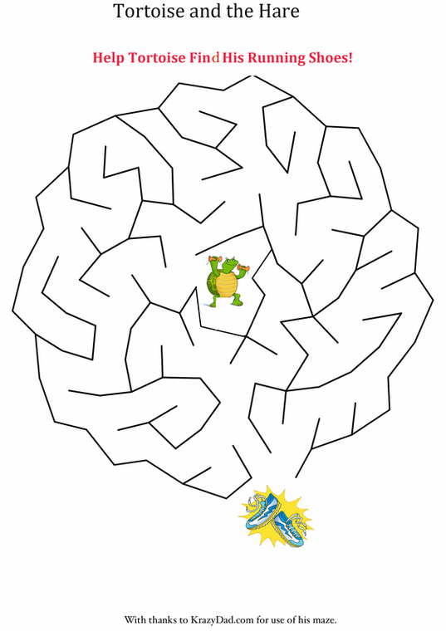

Remember: Check out newsletters and school photos on the school’s website
www.britishschoolbenghazi.org

