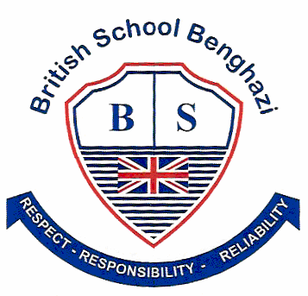
BSB NEWSLETTER

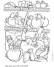

26 October, 2017

Certificates
Teachers appreciate those students who work hard, do well at school or do good things for others. To show that teachers notice when students do well either academically or socially, teachers have awarded them certificates.

12 October
Reception: Khadija
Year 2: Amna
Year 5: Sarah
Year 6 Mad Minute: Nikhilesh
Arabic
All students from Years 1 to 3 received an award from Ms. Arwa. Congratulations everyone.

October 19
Reception: Osed
Year 2: Jad
Year 3: Osama
Year 4: Mohamed Fadeel
Year 5: Yara
Year 6: Bara

House Teams
Students are busy earning merit points for their house teams. It is good to see students earn merits for their school work or for their good behaviour. At the time of writing this newsletter the house teams had earned the following points.
Blue | Green | Red | Yellow
98 | 164 | 211 | 124

After-school Activities

Students have been enjoying their after-school activities.
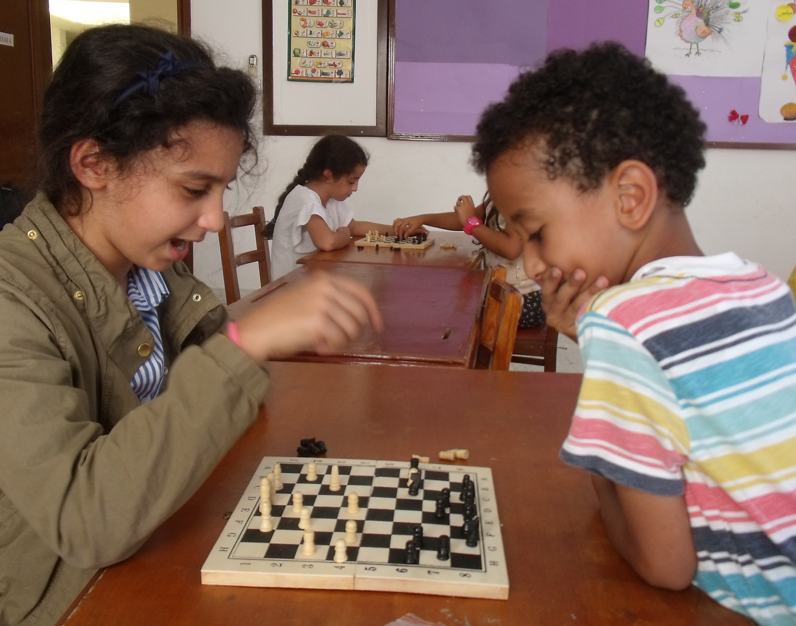
What is your next move?

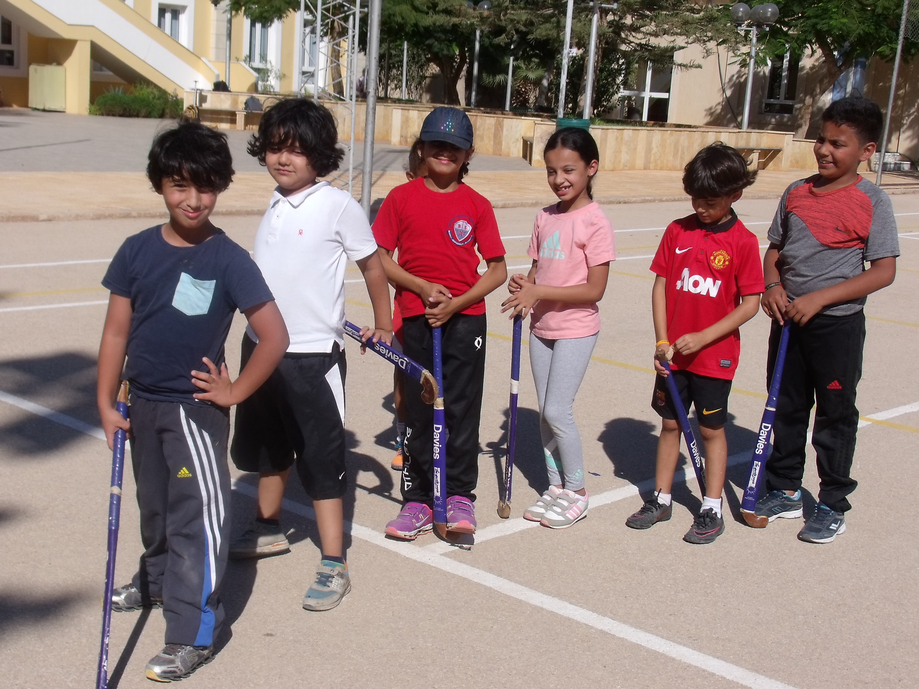
Sports and Games group

BSB Celebrates United Nations Week
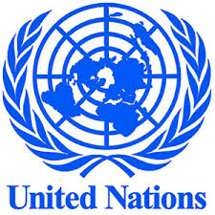
This week the students and staff at BSB participated in our annual UN Week. The theme for this year was ‘People Helping People’.

On Tuesday, students watched a series of video clips showing how people can help other people. A lively discussion followed each clip with students contributing many insightful comments. We are very proud of how well our students can communicate their thoughts.

On Wednesday, students gathered in their house teams to create posters to show how people can help other people. This not only showed how much our students understand that they can help others, but also showed how they can cooperate in a group.
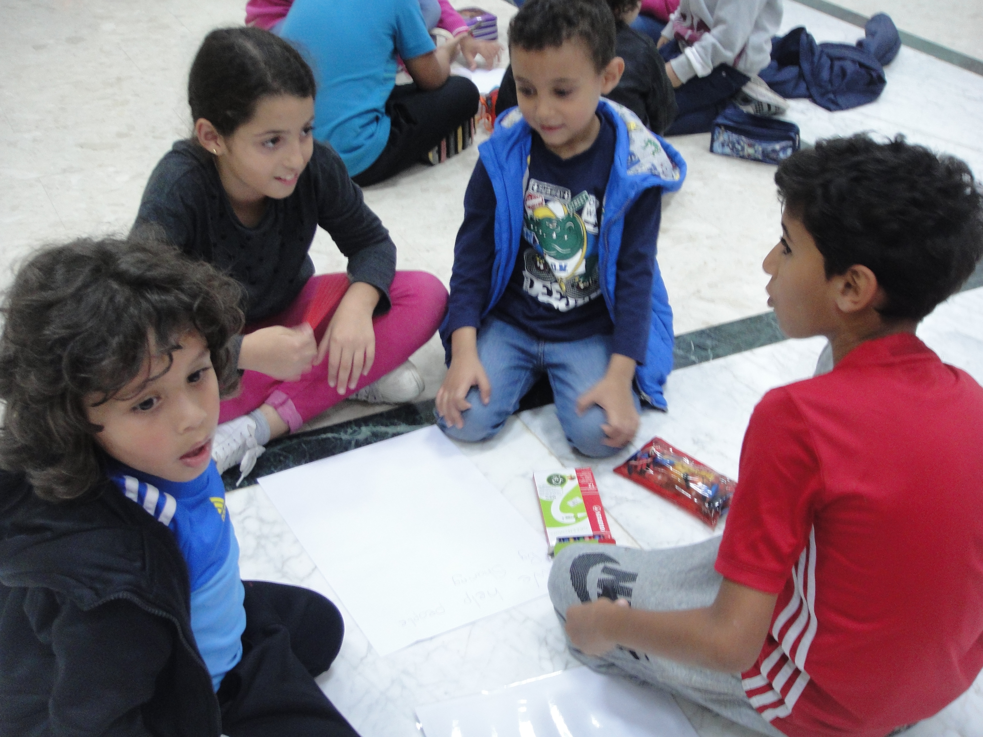
Students work cooperatively on their poster

Students from each year level planted a plant on Thursday to show that we also can help and take care of the Earth. Finally, presentations from each classroom ended UN week. The infant classrooms made presentations on how they can help others. The juniors researched and made presentations on important people who have helped others.

Families have been donating clothing and toys over the past two weeks. These will be given to an orphanage so that the children can have things they need. A big thank you goes to all families who donated to the orphanage. You have shown that there are many ways we can help other people. It’s not too late to give. If you have any items you no longer use, please send them to school next week. We will be putting everything together to deliver it to the orphanage.

We all must thank Mr Mohammed who has organised the week for us.

Like the United Nations, we can all do our part to help other people.

Remember: Check out school photos on the school’s website
www.britishschoolbenghazi.org

