BSB NEWSLETTER

15 February, 2018

Certificates
Teachers appreciate those students who work hard, do well at school or do good things for others. To show that teachers notice when students do well either academically or socially, teachers have awarded them certificates.

1 February
Reception: Ali and Lareen
Year 1 Arabic: Reenad
Year 1 ICT: Jana
Year 2: Bozaid
Year 4: Fatima and Mohamed Q.
Year 4 Arabic: Fatima, Jana, Mohamed A. and
Mohamed Q.
Year 4 ICT: Rimas
Year 5: Narges and Sarah
Year 5 French: Zubair
Year 5 ICT: Rimas B.
Year 5 Arabic: Zaid and Zubair
Year 6: Afnan
Year 6 Mad Minute: Afnan and Suliman

8 February
Nursery: Moftah
Year 1: Zeinub
Year 3: Alia and Dana
Year 5: Yara
Year 6: Bara

Upcoming Assemblies
- Years 1 and 2: Thursday, 22 February
- Reading Week: Thursday, 1 March
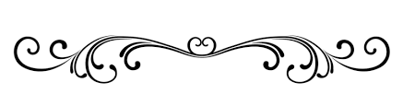

On Sunday, 11 March, the Year 6 students held a Bake Sale. A total of 402.25 LD was raised. When this is added to the money raised at the ice cream sales from Term 1, we have a total of 770 LD. This money will be set aside and added to as the school year progresses. At the end of the third term, we will give all the money to the Children’s Cancer Ward at the Children’s Hospital.
Thank you to the Year 6 students for organising the Bake Sale. We must also thank many of the Year 5 students who also brought something for the sale. Even some students from Years 2 and 3 donated items for the sale. It is good to see students and families of BSB willing to help sick children. We will look forward to other fund raising events as the year moves on.

Production
The rehearsals have been underway for the production of ‘Zoom’ the musical based on the Aesop fable, ‘The Tortoise and the Hare’. Ms Nafeesah, our director, asks that all actors memorise their lines. It is very important that lines are memorised so that blocking and staging can be rehearsed without the need to carry scripts.

Aesop, the Storyteller
There is very little known about Aesop. Some people think Aesop never existed, while others believe he was a slave in ancient Greece. There is no record that Aesop ever wrote anything down. Since he told them over and over and over again, he probably just remembered the stories.
About 2,000 years later, a monk wrote down these wonderful tales of talking animals and little morals. They have been known as "Aesop's Fables" ever since.

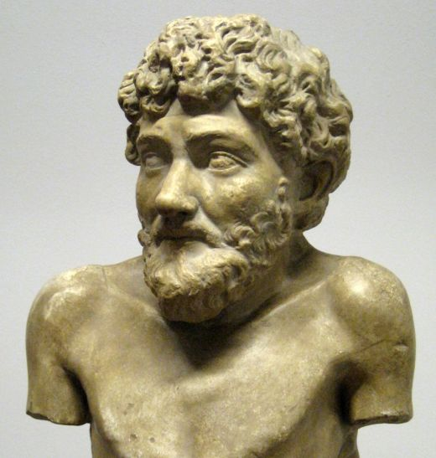
A Greek statue which is thought to be Aesop

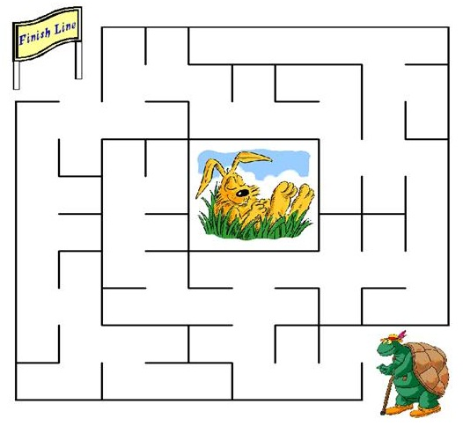
Help Tortoise find the finish line.

Remember: Check out newsletters and school photos on the school’s website
www.britishschoolbenghazi.org

