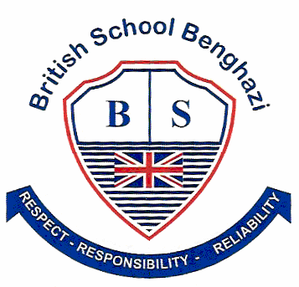
BSB NEWSLETTER

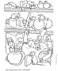

9 November, 2017

Certificates
Teachers appreciate those students who work hard, do well at school or do good things for others. To show that teachers notice when students do well either academically or socially, teachers have awarded them certificates.

26 October
Year 4: Rimas
Year 5: Hamida
Year 6 Mad Minute: Nikhilesh

2 November
Reception: Munjid
Year 3: Alia
Year 5: Narges
Year 6: Yomna
Year 6 IT: Afnan, Nikhilesh, Suliman and Yomna

House Teams
Students are busy earning merit points for their house teams. It is good to see students earn merits for their school work or for their good behaviour. At the time of writing this newsletter the house teams had earned the following points.
Blue | Green | Red | Yellow
135 | 206 | 249 | 143

Parent-Teacher Conferences

The British School will be holding Parent-teacher Conferences on Saturday, 18 November. The purpose of these meetings is to discuss the progress of your child this term.
Your child’s teacher will inform you of the strengths and needs of your child and what you and your child can do to make the first term successful.
Please phone or come to the office to book a time for your meeting. We look forward to seeing you there.
It is the cold and flu season. Remember:
- stay home if you are sick
- wash your hands with soap and water often
- don’t touch your eyes, nose or mouth
- cover your nose and mouth when you cough or sneeze

UN Week Donations Go To Charity

On Saturday, 4 November, Mr Mohamed delivered the donations from BSB to the Sanabil El Heydaya Charity. The clothes and toys were gratefully accepted by Ms Raeda Abdullah Elshareef.
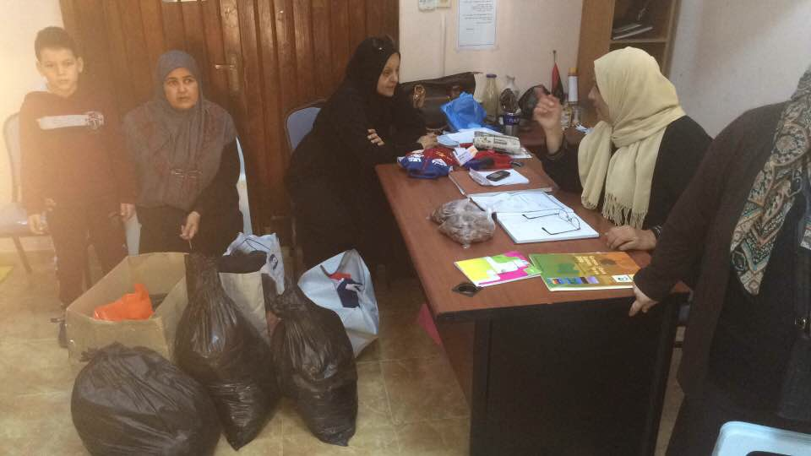
Ms Raeda receives donation from BSB.

Thank you to all the families of BSB for your generous donations.
Reminder: School fees for Term 1 must be paid; this includes both the Dinar and Euro portions.

Baby Animal Names: Some names given for baby animals can seem strange. (taken from Oxford dictionary)
Animal | Baby Name |  | Animal | Baby Name
cattle | calf |  | goose | gosling
camel | calf |  | duck | duckling
whale | calf |  | horse | foal/colt
cat | kitten |  | kangaroo | joey
rabbit | kitten |  | fish | fry
skunk | kitten |  | owl | owlet
dog | pup |  | swan | cygnet
rat | pup |  | spider | spiderling
bear | cub |  | pigeon | squab
tiger | cub |  | frog | tadpole

Can you find your way through this difficult maze? start →

Remember: Check out newsletters and school photos on the school’s website
www.britishschoolbenghazi.org

