BSB NEWSLETTER

15 March, 2018

Certificates
Teachers appreciate those students who work hard, do well at school or do good things for others. To show that teachers notice when students do well either academically or socially, teachers have awarded them certificates.

1 March
Reception: Fareedah
Year 1: Youssef
Year 3: Farida
Year 5: Hamida
Year 5: Malk
Year 5 Arabic: Mariam
Year 6 Mad Minute: Afnan Nikhilesh, Suliman and Thabit

8 March
Year 4: Fatima and Mohamed Q.
Year 5: Meral
Year 5 French: Sarah and Zubair
Year 6: Yomna
Year 6 Mad Minute: Afnan and Nikhilesh

Upcoming Assemblies
- Talent Show – Thursday, 22 March at 11:00 am.

Spring Break
- School will close on Thursday, 22 March at 12:00 noon.
- School will open for Term 3 on Wednesday, 28 March at 8:00 am.

Production
Notice:
- Rehearsals will begin immediately after Spring Break on Wednesday, 28 March.
- All actors must work hard at memorising their lines.
- A note will be sent home next week asking for clothing to use as costumes for the play. Please send everything to school immediately after the Spring Break. Thank you.
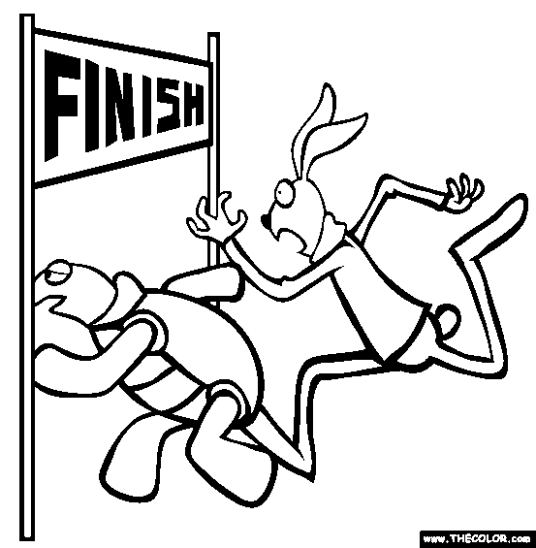

The Tortoise and the Hare

by Aesop

There once was a speedy hare who bragged about how fast he could run. Tired of hearing him boast, the tortoise, challenged him to a race. All the animals in the forest gathered to watch.
Hare ran down the road for a while and then and paused to rest. He looked back at Tortoise and cried out, "How do you expect to win this race when you are walking along at your slow, slow speed?"
Hare stretched himself out alongside the road and fell asleep, thinking, "There is plenty of time to relax."
Slow and steady, Tortoise walked and walked. He never, ever stopped until he came to the finish line.
The animals who were watching cheered so loudly for Tortoise, they woke up Hare.
Hare stretched and yawned and began to run again, but it was too late. Tortoise was over the line.
After that, Hare always reminded himself, "Don't brag about your lightning speed, for slow and steady won the race!"

Tortoise Jokes

1. What was the tortoise doing on the highway?

2. Where do you find a tortoise with no legs?

3. What do you get if you cross a tortoise and a
porcupine?

Answers: 1) about 100 millimetres per hour 2) where you left it 3) a slow poke

Challenging
Find where to begin. Then find your way through the maze to the centre.
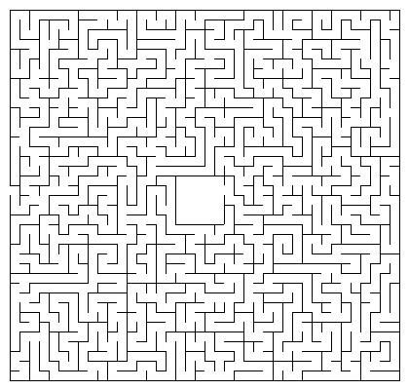

Remember: Check out newsletters and school photos on the school’s website
www.britishschoolbenghazi.org

