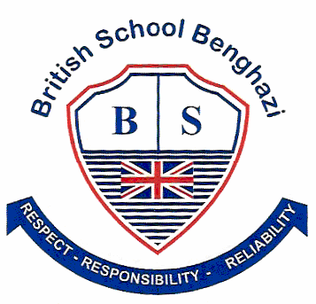
BSB NEWSLETTER

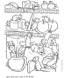

28 September, 2018

Welcome Back
It is good to back at BSB for another school year. I know students were excited to see their friends again after the summer holiday. We are especially pleased to be able to welcome many new families to our school. Our school may be small, but it is big in spirit.

Certificates
Teachers appreciate those students who work hard, do well at school or do good things for others. To show that teachers notice when students do well either academically or socially, teachers have awarded them certificates.

14 September
Year 3: Farida Gadir
Year 4: Fatima Elsahli
Year 5: Remas B.

Meet the Teacher Afternoon
The staff of BSB would like to thank all parents who attended the ‘Meet the Teacher’ afternoon last Wednesday. We appreciate your interest in your child’s learning at BSB.

Textbooks and Library Books
All books at the school are the property of the British School Benghazi. Whether they are textbooks or library books, we expect students and their families to treat them with care. These books are very difficult and expensive to bring from the UK. Please do not write in any of these books. Help young children understand that they must be careful not to tear pages. We want all students to be able to learn from and enjoy the books at BSB.

After-school Activities
We are happy to be able to offer after-school activities to students this term. Remember, this is voluntary. Your child does not have to participate.
Your child will have been given an activity sign-up sheet. On the sheet you may pick a first and second choice. If your first choice is unavailable, then your child will be given his/her second choice.
All sign-up sheets must be returned by Monday, 2 October.
Healthy Eating
We try to encourage healthy eating habits at school. That is why there are no crisps (chips) or sweets allowed in students’ snacks. Sandwiches, fresh fruits and vegetables and a biscuit provide healthy nutrition and energy for a growing child. Children should eat breakfast before coming to school.

Dress Code
- Students are not to wear bracelets, necklaces or long earrings. Short ‘stud’ style earrings are fine.
- Students with long hair must keep it neatly tied back.
- No make-up or nail polish is allowed at BSB.
- Shirts must cover the shoulders.
- Sandals are allowed, but students are not allowed to wear flip-flops to school.

PE Kit
Students must have proper footwear when attending PE lessons. Trainers or running shoes must be worn for every lesson. Students who cannot attend a PE lesson must have a note from a parent or have a parent call the office and leave a message for the PE teacher.

School Times
All children should be at school before the bell rings at 8:00. Students who arrive late not only interrupt the lesson, but miss out on important morning routines.
School finishes at 2:10 and we are pleased to see most parents arranging to have their children picked up by 2:30. Thank you everyone. The staff cannot properly supervise children after 2:30.

Remember: Check out school photos on the school’s website
www.britishschoolbenghazi.org
